**What is Networking? Walkthrough**

**Begin learning the fundamentals of computer networking in this bite-sized and interactive module.**

**Task 1: What is Networking?**

|  |  |
| --- | --- |
| **Question** | **Answer** |
| What is the key term for devices that are connected together? | Network |

**Task 2: What is the Internet?**

|  |  |
| --- | --- |
| **Question** | **Answer** |
| Who invented the World Wide Web? | Tim Berners-Lee |

**Task 3: Identifying Devices on a Network**

|  |  |
| --- | --- |
| **Question** | **Answer** |
| What does the term "IP" stand for? | Internet Protocol |
| What is each section of an IP address called? | Octet |
| How many sections (in digits) does an IP address have? | 4 |
| What does the term "MAC" stand for? | Media Access Control |

* Click on the **“View Site”** button
* To obtain the flag, perform a MAC address spoofing. (Note: MAC address spoofing involves changing the device's MAC address to a different one.)
* For this task, change Bob's MAC address to match Alice's, and then click on "Request Site." (Congratulations, you have obtained your first flag.)

|  |  |
| --- | --- |
| **Flag** | **THM{YOU_***_**_***HACK**}** |

**Task 4: Ping (ICMP)**

|  |  |
| --- | --- |
| **Question** | **Answer** |
| What protocol does Ping use? | ICMP |
| What is the syntax to ping 10.10.10.10? | ping 10.10.10.10 |

* Click on the “View Site” button
* Type in the given IP address and click on send ping request
* You have your flag

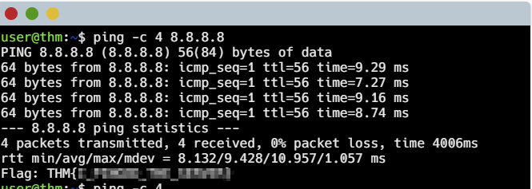

|  |  |
| --- | --- |
| **Flag** | **THM{*_PINGED_***_******}** |